**Exercise 1: Ranking and Window Functions**

Goal: Use ROW_NUMBER(), RANK(), DENSE_RANK(), OVER(), and PARTITION BY.

Scenario:Find the top 3 most expensive products in each category using different ranking functions.

Steps:

1. Use ROW_NUMBER() to assign a unique rank within each category.

2. Use RANK() and DENSE_RANK() to compare how ties are handled.

3. Use PARTITION BY Category and ORDER BY Price DESC.

**Output:**

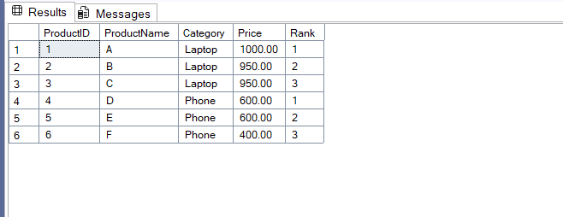

**Query:**

